**Guidance on Home Visiting for QUB Medical Students Academic Year 2024-25**

**Home visits**

The GP consultation is at the heart of general practice, but the number of home visits undertaken is reducing, primarily due to workload pressures. Home visits provide unique rich learning opportunities for undergraduates. These include: -

1. Learning about the patient (in reality) - lifestyle, medication concordance, level of functioning in their home setting
2. Learning about the patient’s home environment (in reality) – relatives/carers/primary care team, deprivation, aids/appliances/adaptations, etc.
3. Developing individual consultation skills and professional values

**Feedback from our medical students across all year groups consistently demonstrates that they enjoy and value seeing patients in their own home.**

Home visits tend to fall into 2 groups: -

1. Reactive (acute deterioration in health)
2. Pro-active (post hospital discharge/chronic condition management when patient unable to attend surgery/palliative care)

For new practices (and those who perhaps haven’t sent students on home visits before), we thought it would be helpful to share a suggested checklist for any GP allocating medical students for a home visit. If you have any ideas/suggestions to add, please let me know.

* Seek patient verbal consent in advance of the home visit (example letter template to patient below, or could include essential info in a text)
* Agree time of visit and check who else will be in the home at the time/any animals?
* Students should complete a home visit in a minimum of two
* Check if students have their own transport or if it is within easy walking distance or can be accessed by public transport within a reasonable timeframe.
* Discuss specific tasks for home consultation eg. Long term condition or multimorbidity information gathering; see student checklist and suggested reflective template.

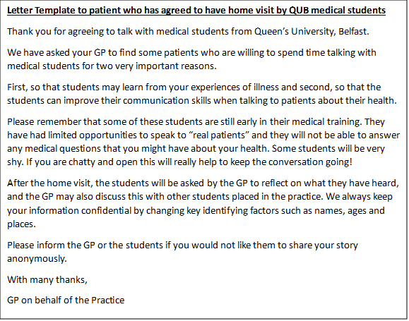

We want to ensure our medical students are adequately prepared for their home visit, so have created a checklist below. Please share any ideas/suggestions. We have also provided a reflective template to help them record their experience.

**BEFORE home visit**

1. Ensure you have patient contact information (address including post code and phone number)
2. Confirm with GP the time you are expected to arrive at the home and time you should be back at the practice, if expected back.
3. Check if you need any patient summary notes provided by the GP.
4. Have a mobile telephone with a contact number for the practice.

**AT home visit**

1. Ensure on entering the house you are speaking to the correct person, confirm with name and date of birth and ensure that they are expecting you.
2. 'A picture paints a thousand words.' Look around to see what you can learn about the patient and their condition from their home life.
3. Consider falls risks, sensory impairment, ability to manage ADLs

* Are there stairs/handrail?
* Are there home modifications?

1. Consider medication and who administers/orders meds.
2. Consider state of home

* Is it an area of deprivation or affluence?
* is it warmer or colder than expected?
* Is it tidy/organised/disorganised?
* Is it in disrepair or good condition?
* does the patient cook or how are nutritional needs met?

1. Make a note of any other relatives or carers who are also at home. If alone, who is their emergency support person?
2. Consider how you vary your consultation style to suit the home environment.
3. Physical examination: You will be guided by your GP tutor as to whether targeted physical examination should be performed. With patient consent you can carry out the following observations on any patient.

* Pulse
* BP
* Oxygen saturation
* Resp rate
* weight

1. Do not perform any intimate physical examination in the home.

**AFTER home visit**

* Debrief with GP tutor – use reflective home visits template.
* Ensure all documentation relating to the visit is shredded at the practice.

